Use this sheet to track benchmarks and new releases
What is "good" data?
There's no such thing as "good data". We can only work out what is "good" based on our own channel and videos.
How data works (simplified)
This is a very simplified explanation of how data works. We need to make sure we don't judge data on its face value and think about who might have seen the videos and how it performed with them.
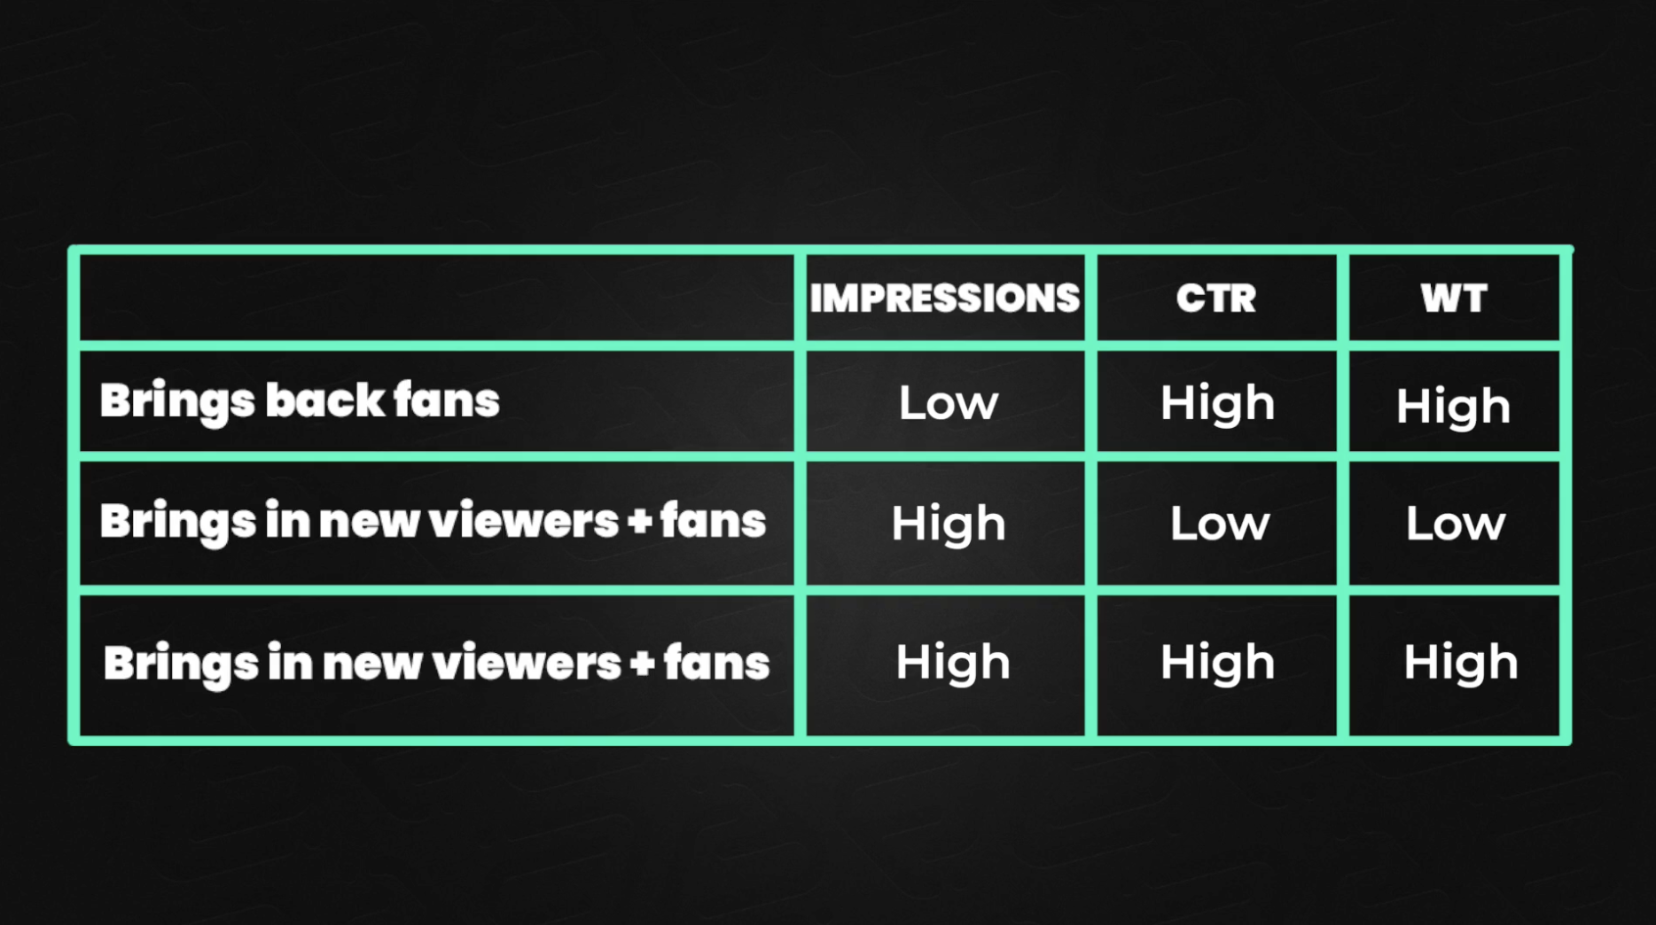
How to work out your videos performance - Establishing benchmarks
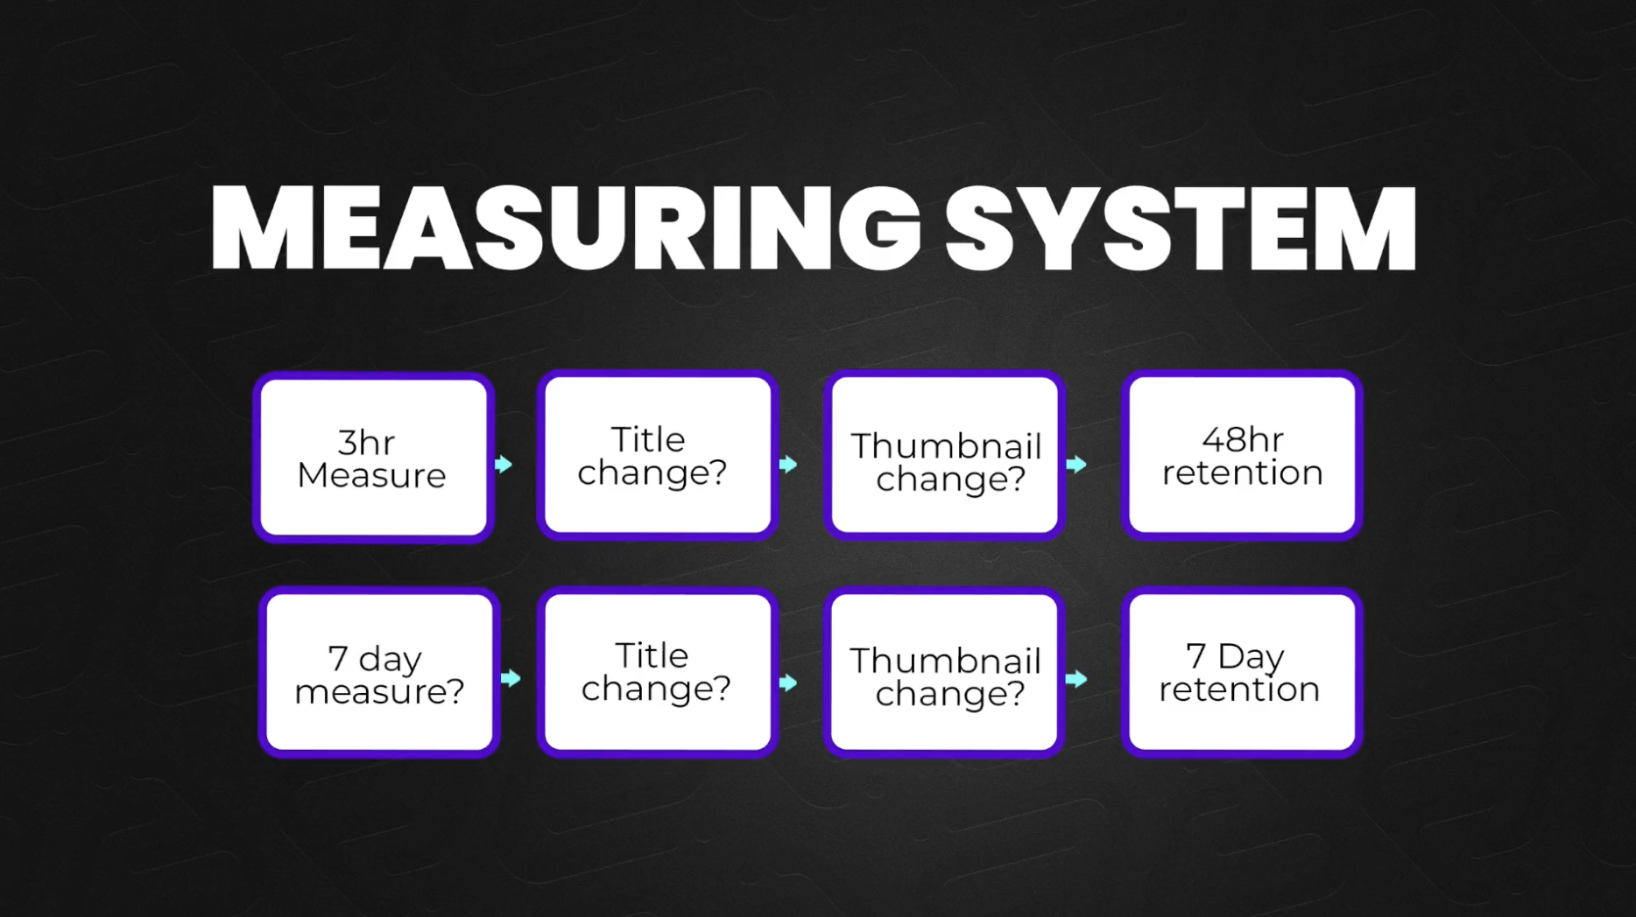
Working out your benchmarks
Step 1: Work out your 3 Hour benchmarks: Open this sheet
Step 2: Go to your last 5-10 videos and track the 3hr views, impressions and watch time in browse.
(Please note on new releases you will track the 3hr CTR too, but its not possible to do this on older videos)
Instructions:
1. Pick a video > Analytics > Advanced Mode > Traffic Sources (change the drop down in the top left to select impressions, then watch time)
2. Slide your mouse over the browse line in the graph until it shows you're at the 3 hour mark.
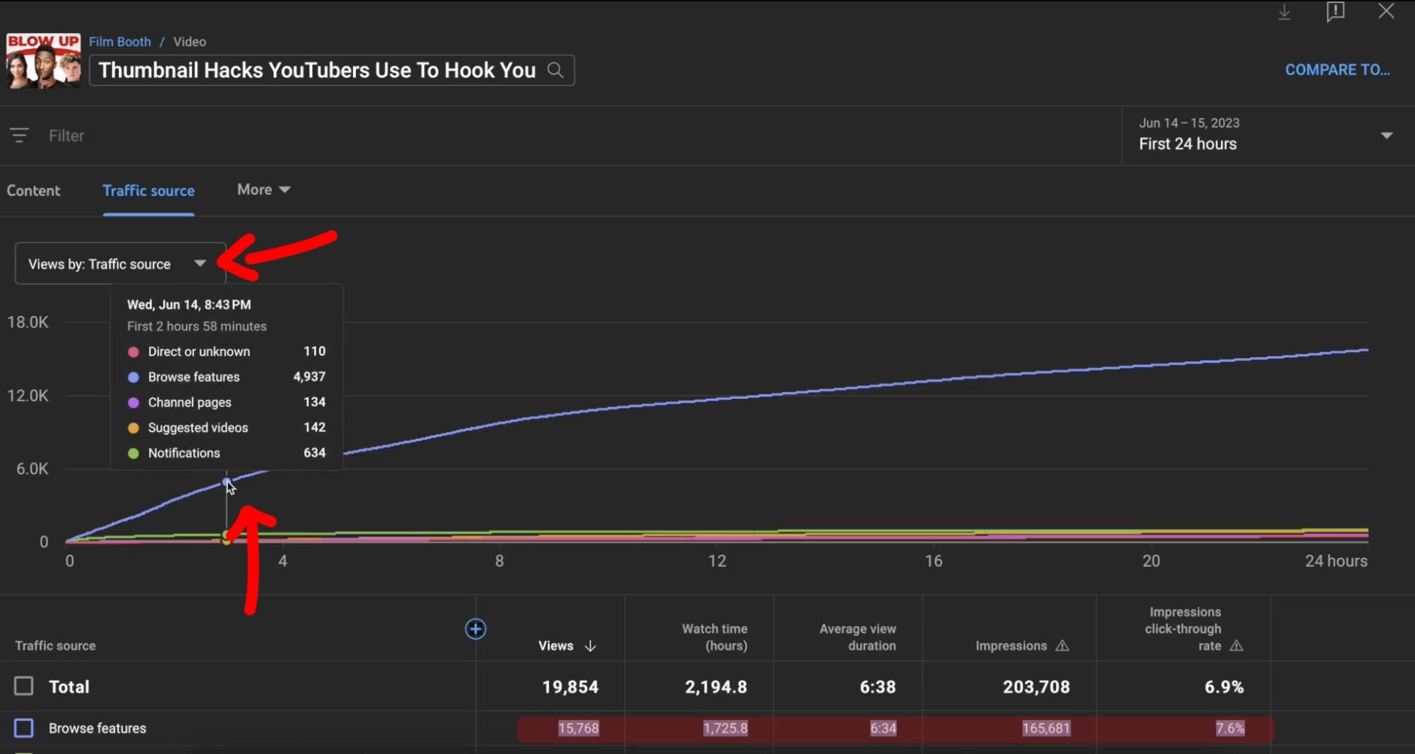
Step 3: Put the data in to your sheet.
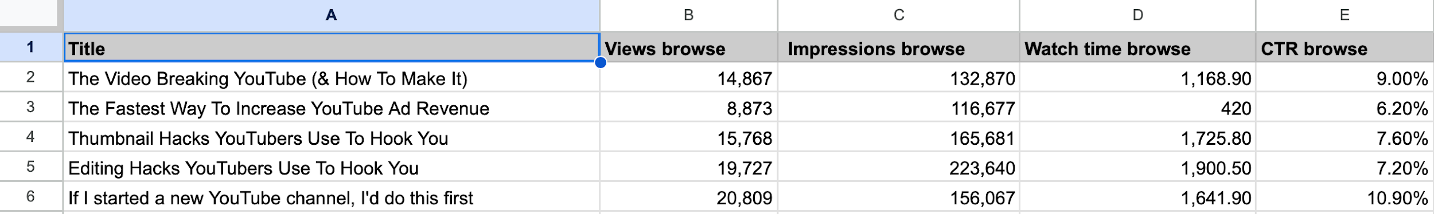
Step 4: Work out what the average data is for each column
You now have an idea of what is "good" for your channel on launch
Step 5: Ask yourself:
What did I expect this video to do on launch?
Why did it get that result?
Step 6: Repeat for the 7 day data
Instructions:
1. Pick a video > Analytics > Advanced Mode > Traffic Sources> Date range (Click first 24 hours, then click the date range again and click "custom" and select the first week)
2. Write down the views, impressions, CTR, watch time data

